**Preliminary Report of Project and Data**

**Prepared for Dr. Edward Crawford of the Virginia Commonwealth University (VCU) Rice Rivers Center**

**Prepared and Submitted by the Leadership Team and Faculty Cohort Participants of the**

**Geospatial Technician Education-Unmanned Aircraft Systems (GeoTEd-UAS) Project**

**GeoTEd-UAS Faculty Institute**

**5/21-5/23/2019**



NSF DUE#1601614

Introduction/Background

The Geospatial Technician Education- Unmanned Aircraft Systems (GeoTEd-UAS) project leadership team coordinated and led the 2019 UAS Faculty Institute to support further professional development of faculty cohort participants in the GeoTEd-UAS project. The purpose of this project was two-fold: 1) to offer an opportunity for GeoTEd-UAS cohort members to plan and conduct real-world field operations, and 2) to collect data for specific projects desired by the Institute host and partner, the Virginia Commonwealth University’s (VCU) Rice Rivers Center (Center). The Institute was supported by the GeoTEd-UAS project with funding from the National Science Foundation (NSF DUE#1601614). Partners in the GeoTEd-UAS project include Thomas Nelson Community, College, Mountain Empire Community College, Virginia Tech, and the Virginia Space Grant Consortium (VSGC).

Unmanned Aircraft Systems (UAS) represent a modern and robust data collection tool that allows access to areas that can be difficult to reach. UAS can be used to collect large quantities of different types of data with minimal disruption to delicate habitats. The data collected during the Institute to support the needs of the Center included high resolution imagery with true color cameras, multispectral sensors, near-infrared (NIR), color-infrared (CIR) and red edge bands. Thermal imagery was also collected for specified projects, including the solar panel array at the Boat Dock. All data was collected using various multi-rotor UAS. Each mission was operated under the guidance of FAA Part 107 which regulates commercial small UAS operations. As required by Part 107, each mission was led by a remote pilot certificate holder who served as the remote pilot in command (RPIC). Other Institute participants supported the missions as visual observers, communications crew, and aircraft lookout crew.

The VCU Rice Rivers Center is situated on 342 acres along the James River, which includes a 70-acre wetland restoration site and the LEED Sustainable Walter L. Rice Education Building. The Center desires updated imagery and data to support a variety of projects.

The objective was to collect data using several sUAS vehicles with appropriate sensors. The data collected will be processed into digital maps and other products for the Center to use in their ongoing research.

The primary target was the entire wetlands area on the Center property. Data was collected at low tide and high tide on two consecutive days during the Institute to support the Center’s needs for data at these two tide levels. Faculty participants split into two groups and operated near-simultaneous missions at high and low tides. One group flew missions from the finger pier at the north end of the property while another group operated from the canoe pier near south end of the property. Flights were not exactly simultaneous but were operated within 15 minutes of each other at the two sites. By splitting into a north and a south group for missions, each group was able to maintain visual line of sight of the sUAS for their respective group at all times, as required by Part 107.

Due to the limited operational area for takeoff/landing available at the finger pier, the northern group had to launch and land the sUAS by hand. This introduced several new risks that required mitigation. The first issue is that the mission required one or more people to be closer to the sUAS than would normally be desired, increasing the risk of the vehicle striking a member for the flight crew. To mitigate the possibly of injury, the person launching the sUAS was wearing safety glasses and glove and held the vehicle with both hands above their head during all times when the motors were armed. The second issue was that the sUAS GNSS was not accurate enough to land back on the small pier. This required that the operator manually guide the sUAS into the hands of the ‘catcher.’

While the operation area of the southern area was slightly larger, missions still required manually catching the sUAS upon landing. This group was able to launch the sUAS directly from the boat ramp, not require hand-held launching.

The primary mission goals were to collect, organize, and provide a preliminary analysis of data to support the Center’s needs in the following areas:

1. Wetland area:  
   a. Collecting low and high tide imagery of the entire wetlands at the same time with a variety of sensors. Collection of the data would hopefully support goals such as
   1. Determining cat-tails vs. grasses
   2. Identifying creek channel from mud flat
   3. Identifying woody areas from the wetland areas
   4. Define vegetation coverage including health and types within the marshy area
   5. Identifying shrub vs. tree coverage
   6. Identifying drainage patterns
   7. Identifying potential wet areas
2. Growth and reintroduced subsurface vegetation
3. Photosynthetic hot spots
4. Condition of solar panels at Main Pier
5. Vegetation vigor on the rooftop at the Conference Center
6. High resolution imagery of the entire Rice Center Property ---multi-spectral and RGB missions of the majority of the property were completed as part of the Institute prep and practice missions prior. Data has already been provided to the Center.

Methodology

Data was primarily collected from three primary locations, the north (or finger pier), the canoe pier, and the southern boat dock. A list of all flights, UAS data, personnel, tidal data, and weather conditions is included in appendix A. All imagery was uploaded and mosaicked using DroneDeploy software. Individual images in both the visual and near IR spectrum have been provided in addition to several final products including orthomosaics, point clouds, video files, and 3D mesh. Other deliverables and products can be provided upon request.

Boat/Side Scan Sonar Missions

The Center was interested in capturing underwater imagery of the wetlands creek, specifically along the length of the channel and a small area at the mouth, along the western shoreline. The Center recently planted sub-aquatic vegetation (SAV) in a small plot along the western shore at the mouth of the creek. The underwater imagery was requested to test methods other than visual inspection to monitor growth and extent of SAV beds. Side-scan sonar was used to compile a variety of underwater imagery to help reveal objects and bedforms.

The missions were conducted using Thomas Nelson Community College’s Oceanographic Research Vessel R/V INVESTIGATOR, a 24-foot Carolina Skiff equipped with a Hummingbird Helix 12 MEGA side-imaging sonar unit. The transducer was mounted on the starboard transom of the vessel and operated at three different frequencies (400kHz, 800kHz, and 1200kHz). To capture the 1200kHz sonar imagery, we selected the “MEGA” transducer setting and the lower frequency sonar imagery used the “High Definition” transducer setting. Sonar scans were captured at different tide heights, with water depths at the SAV site ranging from approximately two to three feet. Imagery was captured by using the Waypoint screen shot and sonar recording functions on the Humminbird unit.

Two different types of imagery were produced with the sonar data: screen shots of side-scan sonar screen (of point locations) and mosaic images (covering linear paths). The screen shots were saved on the unit as .PNG files and the mosaic images were compiled using the proprietary Humminbird software “AutoChart” and exported as .KML and .PNG formats.

Results

All data is available for download at this link [https://1drv.ms/f/s!Am2KvGpWMWj4l7JCHxJeVZjB_DJIcQ](https://nam03.safelinks.protection.outlook.com/?url=https%3A%2F%2Flinkprotect.cudasvc.com%2Furl%3Fa%3Dhttps%253a%252f%252f1drv.ms%252ff%252fs%2521Am2KvGpWMWj4l7JCHxJeVZjB_DJIcQ%26c%3DE%2C1%2CDYRvZaUypIHVa3xqmfXlMluqjU1ynF8LMFsiUaj1bsAd0RnmBrEoLjzMRjFb6HrHt78H93N_VxMYaROieUdjesRuPk2FCjLL6Rfz4-NoiOhJnA%2C%2C%26typo%3D1&data=02%7C01%7Ccxcarter%40odu.edu%7C6d377d9dd41d41b0323c08d6f5a451ce%7C48bf86e811a24b8a8cb368d8be2227f3%7C0%7C0%7C636966483441117310&sdata=YkqqdkSSZrkxp9giJYZxK8nItOuLOrqAohUT4y9bMIc%3D&reserved=0)

The deliverables include the following:  
1. RGB mosaic or aerial imagery of tidal wetland and tributaries at both high and low tides.

2. NIR/CIR/multispectral mosaic or aerial imagery of tidal wetlands and tributaries at both high and low tides.

3. NIR/CIR/multispectral reflectance map of aerial imagery of tidal wetlands and tributaries at both high and low tides.

4. NIR/CIR/multispectral indices (NDVI) of aerial imagery of tidal wetlands and tributaries at both high and low tides.  
5. Point cloud of tidal wetland at both low and high tide.

6. 3D mesh of tidal wetland at both low and high tide.  
7. Evidence of solar panel/cell failure

8. Video of rooftop garden

9. Side scan sonar data

Discussion

Limitations for this work include the performance specifications for the thermal and multispectral sensors used to obtain the imagery. Other limitations included the variable cloud cover and/or time of day for various measurements. The coordination of the North and South flights was not always completely in synch. The FLIR VUE PRO R thermal sensor had 640 x 512 pixels, and the measurement accuracy was accurate to ± 5∘C or 5% of reading from -25∘C to +135∘C. (OEMcameras.com accessed on 5-23-2019).

Conclusion/Summary

The data collection objective, including the use of several sUAS vehicles with appropriate sensors was accomplished. The data collected will be processed by the VCU Rice Rivers Center to use in their ongoing research. The data included high resolution imagery with multispectral sensors, including infrared (IR) and red edge bands. Thermal imagery was also collected for the solar panel array. It was discovered that the east most solar panel had a high temperature profile and may be defective.

The GeoTEd-UAS project team can provide additional data, products, and deliverables as requested by the Center. Future projects and courses can also provide deeper analysis and interpretation of the data as requested by the Center. The GeoTEd-UAS project team and all partners in the project wish to think the Center for hosting the workshop and providing a wonderful venue for sUAS instruction and real-world meaningful data collection. We hope you find this data valuable and look forward to working with you more.

Selected Pictures from the Institute are below.

All pictures are available for viewing and download at this link, <https://www.flickr.com/photos/100507224@N04/albums/72157708820645222>

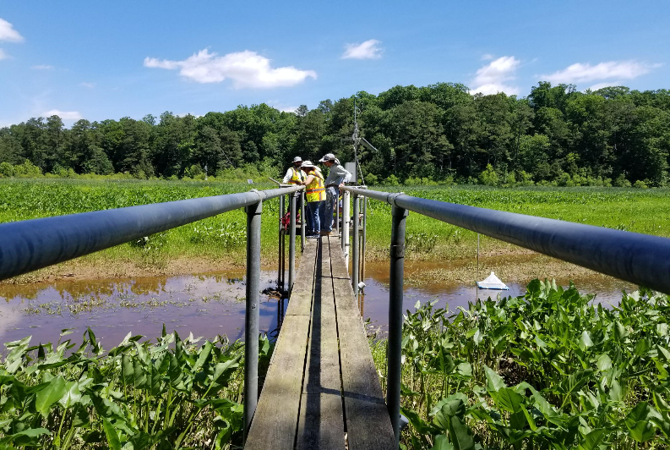

Faculty prepare for sUAS mission at the finger pier on the north end of the wetlands.

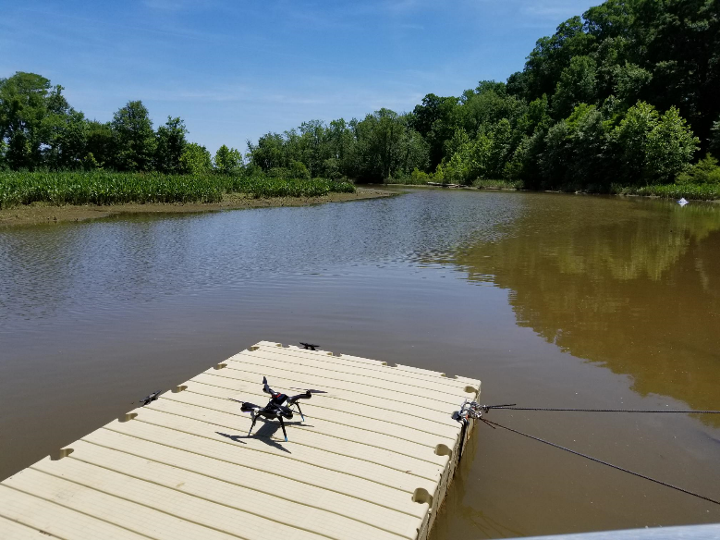

An sUAS prepared for takeoff at the canoe ramp at south end of wetlands.

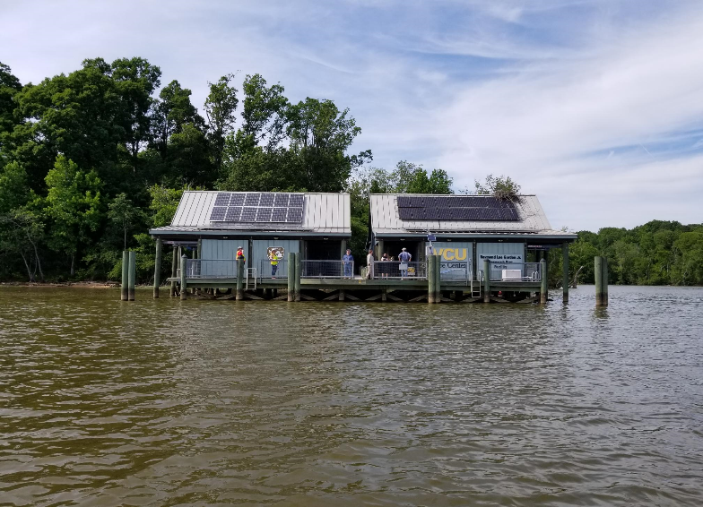

A view of the boat dock from the research boat containing the side-sonar scanner.

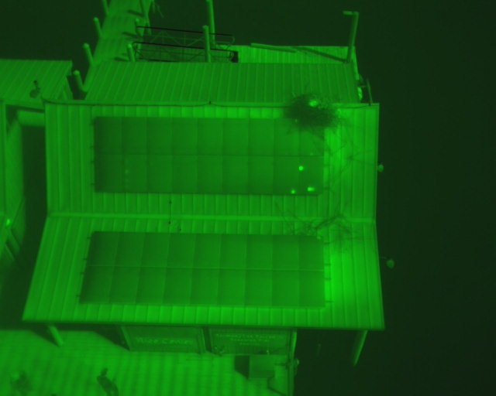

Evidence of some bad solar cells on the solar panels at the boat dock were observed using the thermal camera during a sUAS mission.

References

*APA Style Guidelines-General Format*. (2010, May). Retrieved from Purdue OWL, Online Writing Lab: https://owl.purdue.edu/owl/research_and_citation/apa_style/apa_formatting_and_style_guide/general_format.html

Livingood, N. (2005, June 8). *Purdue Writing Lab.* Retrieved from Writing Engineering Reports: https://owl.purdue.edu/owl/subject_specific_writing/writing_in_engineering/writing_engineering_reports.html

Appendix 1: Mission Summary

|  |  |  |  |  |  |
| --- | --- | --- | --- | --- | --- |
| **Day 1: May 21, 2019** | | | | | |
| Flight Time | Location | Crew Members/Duties | Platform/Sensor | Tide | Weather |
| 12:45 | Canoe Dock | Chris Carter - RPIC  Cherie Aukland - Communication  Kevin Hamed - Ground Crew  Veronica Spradlin - VO  David Webb- VO  John Floyd- VO  Kevin Stilwell - VO  Shawn Shields-Lyons - Lookout  Mark Fitzgerald - Lookout | P4  RGB | Low | Clear |
| 12:45 | Finger Dock | Peter Berquist - RPIC  Daniel Cross - Ground Crew  John McGee - Communication  Scott Reigel - VO  Don Henke - VO  Judy Gill - VO  Chris Blow - VO  Shawn Shields-Lyons - Lookout  Mark Fitzgerald - Lookout | P4  RGB | Low | Clear |
| 13:10 | Canoe Dock | Chris Carter - RPIC  Cherie Aukland - Communication  Kevin Hamed - Ground Crew  Veronica Spradlin - VO  David Webb - VO  John Floyd - VO  Kevin Stilwell - VO  Shawn Shields-Lyons - Lookout  Mark Fitzgerald - Lookout | P3  NIR | Low | Clear |
| 13:10 | Finger Dock | Peter Berquist - RPIC  Daniel Cross - Ground Crew  John McGee - Communication  Scott Reigel - VO  Don Henke - VO  Judy Gill - VO  Shawn Shields-Lyons - Lookout  Mark Fitzgerald - Lookout | Solo  Multispectral | Low | Clear |
| 13:45 | Finger Dock | Peter Berquist - RPIC  Daniel Cross - Ground Crew  John McGee - Communication  Scott Reigel - VO  Don Henke - VO  Judy Gill - VO  Shawn Shields-Lyons - Lookout  Mark Fitzgerald - Lookout | P3  NIR | Low | Clear |
| 16:00 | Kimages Creek | Peter Berquist - Operator  John McGee - Crew | Humminbird  Helix 12 MEGA Side-scan Sonar | N/A | Clear |
| 18:05 | Canoe Dock | Veronica Spradlin - RPIC  Chris Carter- Communication  Chris Blow - Ground Crew  David Webb - VO  John Floyd - VO  Kevin Hamed - VO  Cherie Aukland - VO  Judy Gill - VO  Kevin Stilwell - Lookout  Mark Fitzgerald - Lookout | P4  RGB | High | Clear |
| 18:05 | Finger Dock | Scott Reigel - RPIC  Don Henke - Ground Crew  Daniel Cross - Communication  Shawn Shields Lyons - VO  Kevin Stilwell - Lookout  Mark Fitzgerald - Lookout | P4  RGB | High | Clear |
| 18:30 | Canoe Dock | Veronica Spradlin - RPIC  Chris Carter- Communication  Chris Blow - Ground Crew  David Webb - VO  John Floyd - VO  Kevin Hamed - VO  Cherie Aukland - VO  Judy Gill - VO  Kevin Stilwell - Lookout  Mark Fitzgerald - Lookout | P3  NIR | High | Clear |
| 18:30 | Finger Dock | Daniel Cross - RPIC  Scott Reigel - Ground Crew  Daniel Cross - Communication  Don Henke - VO  Kevin Stilwell - Lookout  Mark Fitzgerald - Lookout | Solo  Multispectral | High | Clear |
| 18:45  Failed Launch | Finger Dock | Daniel Cross - RPIC  Don Henke - Ground Crew  Daniel Cross - Communication  Scott Reigel - VO  Kevin Stilwell - Lookout  Mark Fitzgerald - Lookout | P3  NIR | High | Clear |

|  |  |  |  |  |  |
| --- | --- | --- | --- | --- | --- |
| **Day 2: May 22, 2019** | | | | | |
| Flight Time | Location | Crew Members/Duties | Platform/Sensor | Tide | Weather |
| 10:30  Failed Imagery | Rooftop Garden | Daniel Cross - RPIC  Kevin Hamed - VO  Veronica Spradlin - VO  Cherie Aukland - VO  Chris Blow - VO | Solo  Multispectrum | N/A | Clear |
| 13:12 | Canoe Dock | Mark Fitzgerald - RPIC  Chris Carter - Communication  Shawn Shields Lyons - Ground Crew  David Webb- VO  Kevin Stilwell - VO  Molly Henschel - Consultant  Judy Gill - Lookout  Veronica Spradlin - Lookout | P4  RGB | Low | Clear |
| 13:30 | Canoe Dock | Shawn Shields Lyons - RPIC  Chris Carter - Communication  Mark Fitzgerald - Ground Crew  David Webb- VO  Kevin Stilwell - VO  Molly Henschel - Consultant  Judy Gill - Lookout  Veronica Spradlin - Lookout | P4  RGB | Low | Clear |
| 13:12 | Finger Dock | Chris Blow - RPIC  Kevin Hamed - Ground Crew  Daniel Cross - Communication  Scott Reigel - VO  John McGee - VO  Judy Gill - Lookout  Veronica Spradlin - Lookout | P4  RGB | Low | Clear |
| 13:30 | Finger Dock | Chris Blow - RPIC  Kevin Hamed - Ground Crew  Daniel Cross - Communication  Scott Reigel - VO  John McGee - VO  Judy Gill - Lookout  Veronica Spradlin - Lookout | Solo  Multispectral | Low | Clear |
| 14:00 | Canoe Dock | Kevin Hamed - RPIC  Chris Blow - Ground Crew  Daniel Cross - Communication  Scott Reigel - VO  John McGee - VO  Judy Gill - Lookout  Veronica Spradlin - Lookout | Solo  Multispectral | N/A |  |
| 14:30 | Boat Dock  Solar Panels | Kevin Hamed - RPIC  Daniel Cross - Communication  Scott Reigel - VO  Kevin Stillwell - VO | Solo  Thermal Imaging | N/A | Clear |
| 14:40 | Boat Dock  Solar Panels | Chris Blow - RPIC  Daniel Cross - Communication  Don Henke - VO  Shawn Shields Lyons - VO  Judy Gill - VO | Solo  Thermal Imaging | N/A | Clear |
| 14:50 | Boat Dock  Solar Panels | Shawn Shields Lyons - RPIC  Chris Blow - Ground Crew  Daniel Cross - Communication  Don Henke - VO  Judy Gill - VO | Solo  Thermal Imaging | N/A | Clear |
| 15:00 | Boat Dock  Rooftop Garden | Judy Gill - RPIC  Chris Blow - Ground Crew  Daniel Cross - Communication  Don Henke - VO  Shawn Shields Lyons - VO | Solo  Thermal Imaging | N/A | Clear |