DEVELOPMENT OF A FUNCTION GENERATOR FOR PLASMA-ASSISTED COMBUSTION
Myles Perry¹
¹Old Dominion University Department of Electrical and Computer Engineering

Abstract
Plasma-assisted combustion (PAC) has emerged as a promising solution for extending the flammability limits of fuels. This stabilizes combustion, useful in extreme conditions or for alternative fuels, such as in scramjet propulsion and ammonia-based fuels. This study presents the design and implementation of a function generator capable of producing the high-frequency, high-voltage, and phase-shifted waveforms required to generate a uniform electric field within a custom gas tube electrode. Using an Arduino Giga microcontroller, digital-to-analog converters, and analog operational amplifiers, eight synchronized waveforms with 45° phase differences were generated and verified. While output waveforms exhibited distortion, the system successfully ionized helium gas, confirming proof of concept. This work demonstrates a foundational step toward enabling PAC systems for advanced propulsion and low-emission energy applications.
Introduction
This study has two problems motivating its area of investigation. First, the development of scramjet engines has been hindered by the unreliable combustion of hydrocarbon fuels at extreme conditions (high altitude and hypersonic speed). The unique environment of scramjets closely approaches the flammability limits—the stoichiometry and environment necessary for ignition—of this combustion reaction. Plasma-assisted combustion (PAC) has been suggested to extend the flammability conditions, potentially enabling higher speeds for scramjet engines¹.
Second, significant research interest in ammonia-based (NH₃) fuel has arisen in recent decades². These fuels release fewer greenhouse gases than hydrocarbons. However, they release nitrogen oxides (NO_{x}), a component of visible smog. Previous research has shown that ionizing ammonia-based fuel produces less NO_{x} pollutant upon combustion.
This technology presents clear practical applications. However, physical characteristics of the system present challenging technical limitations. First, in order to create a uniform plasma throughout the entire fuel a rotating electric field is required. To achieve this, electrodes are placed along the height of a gas tube, spaced equally along the circumference of the tube’s cross section:
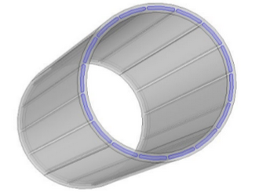
Figure A: Electrode Geometry
Next, alternating voltage waveforms are applied to each electrode according to the following equation:
$$\begin{aligned}V_{R}\left(θ,t\right)=V_{0}\cos\left(ωt+nθ\right)\#\left(2\right)\end{aligned}$$
Where θ is the angular position of the electrode along the circumference. The inner volume of the tube then exhibits an electric field according to the following equation:
$$E\left(r,θ\right)=n\frac{V_{0}}{R}{\left(\frac{r}{R}\right)}^{n-1}∙$$
$$\begin{aligned}\left[-\cos\left(ωt+nθ\right)\vec{e_{r}}+\sin\left(ωt+nθ\right)\vec{e_{θ}}\right]\#\left(3\right)\end{aligned}$$
High voltage and high frequency are used to ionize gases and keep them uniformly contained within the volume of the gaseous tube. The ideal path of the ions is illustrated in the following figure:
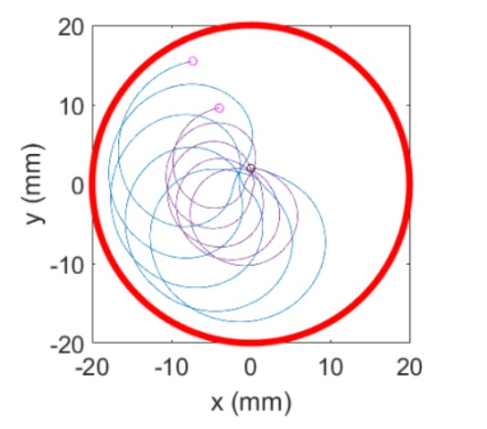
Figure B: Trajectory of Nitrogen Ion at 35kHz (Blue) and 77kHz (Purple)
This study designs a function generator capable of producing the necessary voltage waveforms as described by equation (2) and figure A.
Function Generator Design Requirements
Producing the necessary electric field conditions for atmospheric plasma requires eight synchronous voltage waveforms phase-shifted by 45° relative to each other. In order to produce differing field conditions required for different gases, amplitude and frequency of each waveform must be tunable.
Function Generator Implementation
Component Overview
To achieve flexible control over the frequency and phase shift of each waveform, an Arduino Giga microcontroller unit (AGMCU) is first used to produce digital waveforms. To convert these digital signals to analog signals, DAC 908 chips from Texas Instruments were employed. The 908’s analog outputs are amplified with Texas Instrument’s voltage-controlled operational amplifiers LM13700. These amplifiers enable simultaneous control of the waveform amplitude. Finally, these are buffered with OP27 operational amplifiers, used to drive greater current with each waveform. Overall, an AGMCU, DAC 908s, LM13700s, and OP27s are all implemented in this design.
Signal Pathway
An AGMCU generates four 8-bit digital waveforms at 0°, 45°, 90°, and 135° phase shift. These are each routed to a DAC 908, which outputs two inverse analog signals. These two signals are routed to an LM13700, which in turn produces two amplified analog outputs inverted with respect to one another. Note that these inverted analog outputs are equivalent to phase shifting each signal by an additional 180°. This completes the set of eight required phase-shifted waveforms: 180°, 225°, 270°, and 315°. All eight waveforms are run through an OP27 configured as a buffer. A diagram of this is given in figure C below:
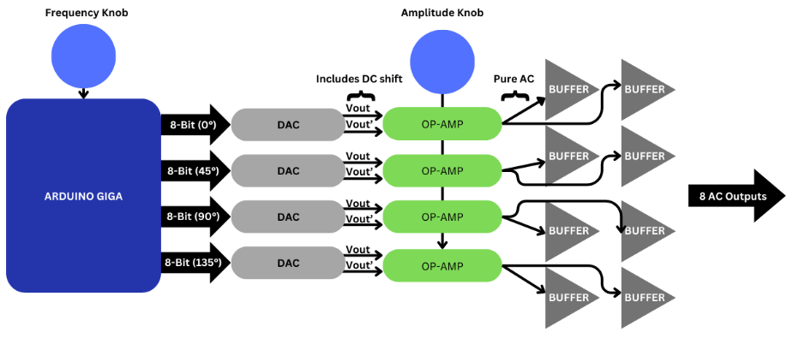
Figure C: Signal Routing Diagram

Final Assembly
The AGMCU, DAC 908s, LM13700s, and miscellaneous passive circuit components were connected via a printed circuit board (PCB). The OP27 buffers were connected via a breadboard with discrete wires. The PCB and breadboard, along with a power supply and I/O interface were all housed within a sheet metal chassis. This is shown below in figure D:
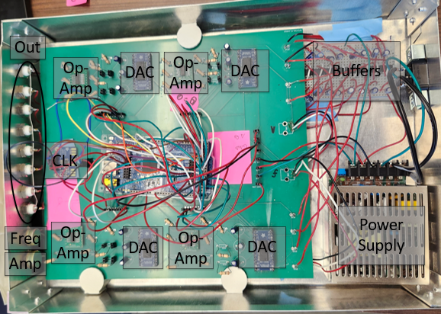
Figure D: Function Generator
The outputs from this function generator were connected to the additional amplifiers and then the electrodes on the gas tube. This is shown below in figure E:
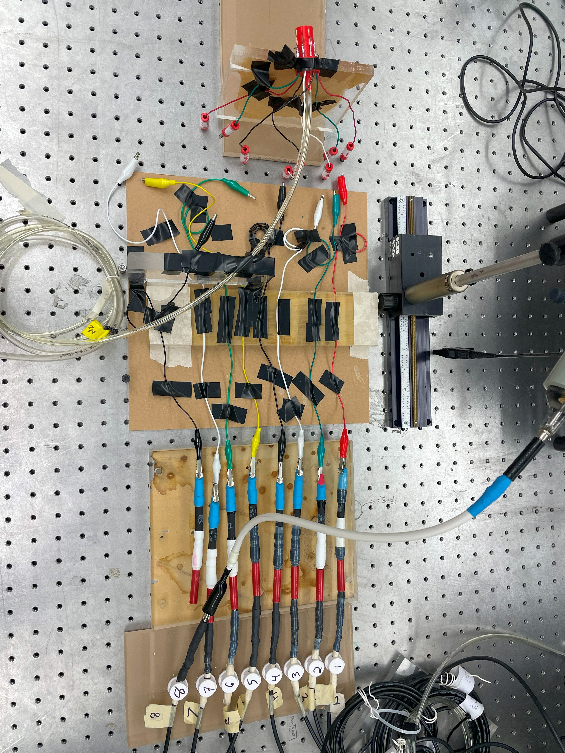
Figure E: Electrode and Gas Tube Experimental Setup
Preliminary Results
Once the function generator was constructed, its outputs were verified using an oscilloscope:
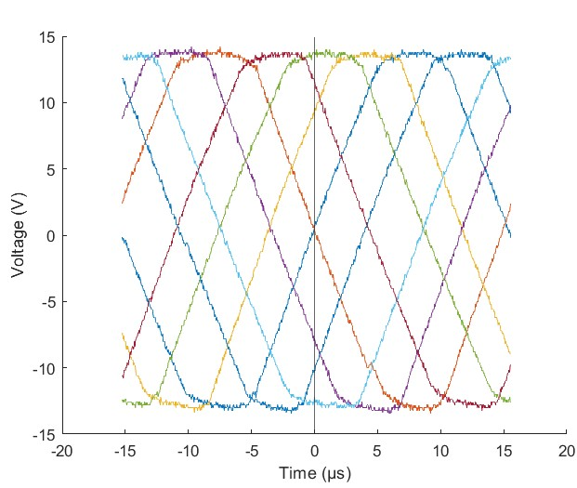
Figure F: Voltage Waveforms from Function Generator with Eight Symmetrical Phase Shifts
Figure F verifies that each waveform is shifted 45° apart. However, the expected sinusoidal waveforms were not observed. Instead, distorted bipolar triangle waves are observed. The triangular shape of the waveforms could be explained by slew-limitation of one of the amplifiers. The minimum slew rate for a given sinusoidal waveform to not be distorted is given by³:
$$\begin{aligned}SR≥V_{0}2πf\#\left(4\right)\end{aligned}$$
Therefore the minimum slew rate when V₀ is 15 V and the frequency is 10kHz is:
$$\begin{aligned}SR_{min}=0.942\frac{V}{μs}\#\left(5\right)\end{aligned}$$
According to the OP27 data sheet, the slew rate ranges from 1.7 V/µs to 2.8 V/µs⁴. According to the LM13700 data sheet, the slew rate has a typical value of 50 V/µs⁵. This suggests that neither amplifier is slew limiting.
Despite the unknown reason for distortion, the function generator was still implemented as-is to generate plasma. As proof of concept, ionization of helium gas was attempted. Helium is relatively easy to ionize compared to heavier gases, such as methane and ammonia. For this reason, it establishes a lower bound for the system’s ability to ionize gas. At a pressure of 10cc and a flow rate of 100 cc/s, the following plasma was observed:
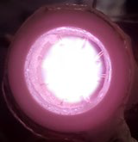
Figure G: Helium Plasma Observed in Gas Tube Electrode
This establishes that the function generator is capable of producing the minimum conditions for plasma generation.
Conclusion
This project has demonstrated that the novel gas tube electrode design is capable of producing plasma. Additionally, this study validates the design of the function generator as one capable of reaching the voltage and frequency needed to ionize helium.
However, the end goal of this technology is to demonstrate a uniform plasma of combustible gaseous fuel. Future research should continue to implement the technology validated here. In order to achieve ionization of these fuels, higher voltage may be required.
Literature Cited
[1] Barber, A. T., Maicke, B. A., Majdalani, J., “Current State of High Speed Propulsion: Gaps, Obstacles, and Technological Challenges in Hypersonic Applications,” 45th AIAA/ASME/SAE/ASEE Joint Propulsion Conference & Exhibit, 2 - 5 August 2009, Denver, Colorado
[2] Radwan, A. M., Manosh, C.P., “Plasma assisted NH3 combustion and NOx reduction technologies: Principles, challenges and prospective,” International Journal of Hydrogen Energy, vol. 52, part A, pp. 819-833, 2024.
[3] Adel S. Sedra, K. C. (2020). Microelectronic Circuits 8th Ed. New York: Oxford University Press
[4] Texas Instruments, “Low Noise, Precision Operational Amplifier,” OP27 datasheet, Feb. 1989 [Revised Feb. 2010].
[5] Texas Instruments, “LM13700 Dual Operational Transconductance Amplifiers With Linearizing Diodes and Buffers,” LM13700 datasheet, Nov. 1999 [Revised Nov. 2015].

